Hadoop on k8s

1）下载hadoop和zk的yaml定义服务

*git clone https://github.com/k8sp/hadoop.git*

定义文件：

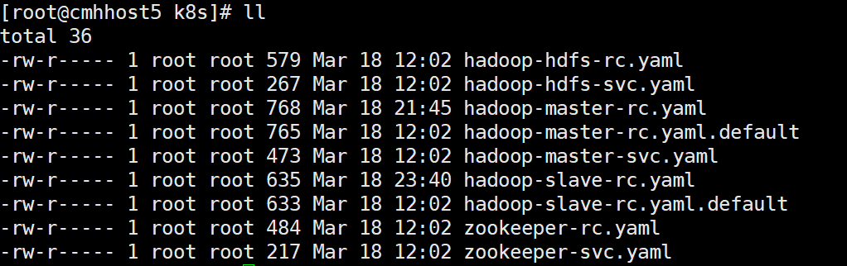

2）部署HDFS，命令如下：

*kubectl create -f hadoop/hadoop-hdfs-rc.yaml*

*kubectl create -f hadoop/hadoop-hdfs-svc.yaml*

3）部署ZK，命令如下：

*kubectl create -f hadoop/zookeeper-rc.yaml*

*kubectl create -f hadoop/zookeeper-svc.yaml*

4）获取zk的ip及HDFS host

*# kubectl get svc*

*NAME CLUSTER-IP EXTERNAL-IP PORT(S) AGE*

*dns-backend 172.15.112.233 <none> 8000/TCP 15h*

*hadoop-hdfs 172.9.16.110 <none> 9000/TCP,50070/TCP 13h*

*hadoop-zookeeper 172.8.243.164 <none> 2181/TCP 3h*

基于hadoop-master-rc.yaml.default来创建hadoop-master-rc.yaml

*sed "s/<ZOOKEEPER_ADDR>/172.8.243.164:2181/g" hadoop-master-rc.yaml.default | sed "s/172.9.16.110/10.0.0.114/g" > hadoop-master-rc.yaml*

5）创建hadoop master pod和service

*kubectl create -f hadoop/hadoop-master-rc.yaml*

*kubectl create -f hadoop/hadoop-master-svc.yaml*

6) 部署Hadoop NM

*# kubectl get svc hadoop-master*

*NAME CLUSTER-IP EXTERNAL-IP PORT(S) AGE*

*hadoop-master 172.14.118.23 <none> 8088/TCP,8033/TCP,8032/TCP,8031/TCP,8030/TCP,8090/TCP 1h*

基于hadoop-slave-rc.yaml.default创建hadoop-slave-rc.yaml

*sed "s/<RM_HOSTNAME>/172.14.118.23/g" hadoop-slave-rc.yaml.default | sed "s/<HDFS_HOST>/172.14.118.23/g" > hadoop-slave-rc.yaml*

创建hadoop node manager pod

*kubectl create -f hadoop/hadoop-slave-rc.yaml*

至此创建成功。

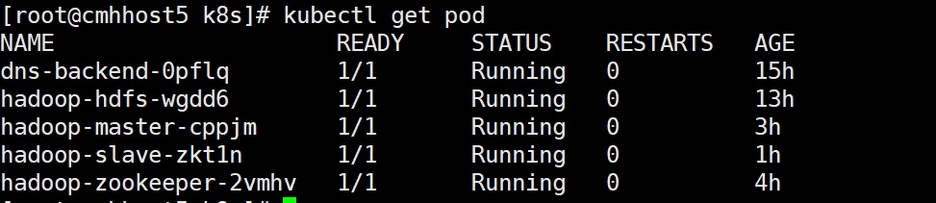

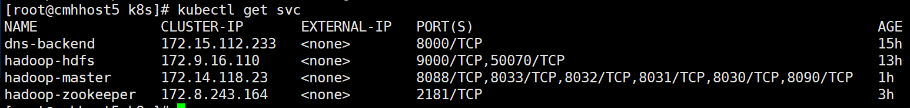

打开RM Web，如下：

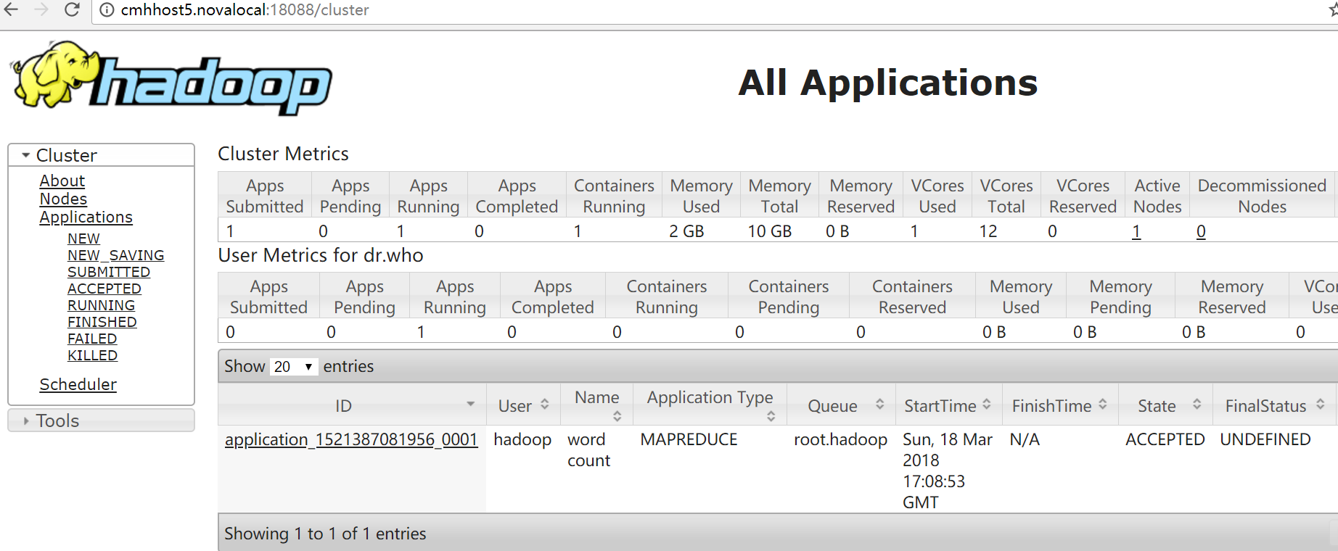

7）执行MR Job

*# kubectl exec -ti hadoop-master-cppjm /bin/bash*

*root@hadoop-master-cppjm:/opt/hadoops# pwd*

*/opt/hadoops*

*root@hadoop-master-cppjm:/opt/hadoops# ls*

*hadoop hdfs input run_wordcount.sh*

参考链接：

https://github.com/k8sp/hadoop